**Physiotherapy New Zealand**

**2020 Annual Budget Process – Guide**

**Financial Year 1 July 2020 to 30 June 2021**

**Annual Budget Process**

In line with the Change Programme framework the stages and timeframes for the annual business planning and budgeting cycle is set out in the following:

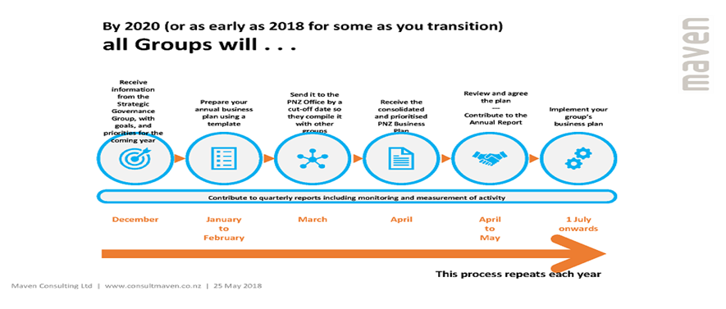

**Overview**

**GST**

### All Groups in the unified PNZ model are subject to PNZ's GST registration.

**What this means**

Groups that were previously registered for GST will see NO CHANGE.

Groups NOT previously registered for GST the following outlines the changes for budgeting purposes:

**INCOME** - All income, including membership subscriptions and course fees, is subject to GST from the date each Group joins unified PNZ.

Example: A course charged to a member before unification of $230 will still cost a member $230 however, $30 of this is now be accounted for as GST with $200 recorded as income for that course.

**COSTS** - The GST element of all costs for GST related items can be reclaimed from the IRD, therefore when budgeting costs from suppliers who are GST registered the related GST can be excluded from the budgeted costs. [Note: there is NO GST on mileage or overseas travel]

When preparing your budget **ALL** Income and Cost should **EXCLUDE** GST.

**Payments of Honorarium/ Stipends**

Where Groups have budget for the payment of honorarium or stipends to committee members, these payments are subject to the IRD Scheduler Payment rules, see unified PNZ information on the Website <https://pnz.org.nz/Category?Action=View&Category_id=1203>

**What this means**

For Groups that budget Honorarium or Stipends the total cost of such payments should be included in the budget template, however in accordance with the IRD guidelines the recipient will receive the total amount less Withholding tax (WT). The WT will be paid to the IRD by PNZ under the recipients IRD number.

**Guidelines**

On completion of the Group’s Business Plan for the prescribed financial year it is time to complete the attached excel budget template.

All figures should be entered in the light grey cells ONLY, as positive integers.

**Operating Income**

Any course or subscription income, excluding GST, should be entered here in the month in which the course is scheduled. Subscription income, in the main, comes in during November to February of any year.

**Symposium/ Conference Income**

If a Group is planning a Conference or Symposium this year, the budgeted income should be entered in this area, excluding GST included in the ticket prices.

**Other Income**

Any other income expected by the Groups should be entered here, remember that if your Group has joined the unified PNZ model funds being placed on term deposit will be managed by the PNZ office and will be budgeted by PNZ. Please specify in your business plan details of other income noted in this area.

**Direct Costs**

Direct costs are those costs which relate specifically to income budgeted in any of the preceding categories.

I.e. the cost associated with bringing speakers in for specific courses, symposium or conferences including travel, accommodation, gifts to speakers etc.

**Overheads & Expenses**

Overhead costs and expense relate to any costs incurred in the running of your Group including committee meetings (catering, venue hire, and travel), Grants or Awards and honorarium for committee members, this category includes payments to compensate[1] committee members for their attendance at external meetings including PNZ Leadership Days etc.

Please do NOT add additional Lines into the excel budget template, instead make a note of additional cost lines required and the PNZ office will update the template and send it back to you.

**General information**

Budgets should be in line with previous years financial operations, submitted Terms of Reference and the current year’s Business Plan.

Note any exceptional items when submitting your information.

If you have any questions please contact Bridget at [accounts@physiotherapy.org.nz](mailto:accounts@physiotherapy.org.nz).

1. These payments are subject to the IRD’s scheduler payment rules.